|  |
| --- |
| Anticoagulation clinic customer information |
| Patient Information Leaflet |

# 

# <https://labmedservices.stockport.nhs.uk>

# 

# Anticoagulant Clinic, Stepping Hill Hospital

**Our Service Commitment to you:**

* We will provide a high quality, professional, clinical and diagnostic service maintaining UKAS Accreditation and achieving good results in National Quality Assurance schemes.
* New patient appointments will be sent promptly in writing or by telephone if urgent. Future appointments will be made before you leave the clinic.
* At your first visit to the clinic you will be counselled by the Anticoagulant Nurse who will fully explain anticoagulant therapy to you.
* You can expect to be dealt with promptly and in a courteous manner.
* You will be advised if clinics are running more than 30 minutes late and by how much.
* Your anticoagulant notes will be available for each appointment.
* You will be provided with a **yellow** anticoagulant record book that contains details of your medication, contact numbers and other important information.
* If you should need to contact the department by telephone you should leave your name and contact number only, on the answer machine. Your answerphone message will receive a response within one working day.
* If you should need to contact the department by email you will receive a response within one working day.
* Where appropriate you will be offered information about procedures and relevant health education. We are unable to give clinical advice this must be sought from your GP.
* You can be offered a choice of location, date and time for your follow up appointment.
* The clinic environment will be kept clutter free to reduce the risk of accidents/falls.

**What is the clinic procedure?**

* Please take a seat in the waiting room.
* A member of clinic staff will call you in for your appointment.
* Your blood test will be taken and measured by a laboratory assistant.
* The nurse or scientist will review your dose for your anticoagulant therapy.
* Your dose will be recorded in your yellow book which shows the amount of milligrams to be taken each day and has your next appointment time and date written on.
* The information with your INR result, dose and next appointment is also transmitted electronically to your GP for your records. (Please ensure that we have up to date information for you - GP, Address, Contact details)
* If you have any questions or concerns please speak to the clinic staff and they will help you.
* If you require a private consultation please make the clinic staff aware of this so a separate appointment can be arranged for you.
* If you need to change your appointment please ring anticoagulation at Stepping Hill on 0161 419 5624 and leave your details on the answer machine or you can also email to change your appointment at [anticoag@stockport.nhs.uk](mailto:anticoag@stockport.nhs.uk)
* Please do not ring the individual surgery where you attend.
* Please note that it may not be possible to give you an appointment at your usual clinic.

**A reminder about missed appointments**

**Oral anticoagulants such as Warfarin and Sinthrome are dangerous drugs that need to be monitored carefully for the safety of the patient.**

A missed appointment results in wasted time of the staff and the reagents used to perform the tests.

Whilst we appreciate on occasion a missed appointment is unavoidable due to illness or emergency; please think ahead and contact the clinic office on **0161 419 5624** to rearrange or cancel your appointment, giving as much notice as possible. This will allow us to allocate your appointment to someone else and to manage your care appropriately.

**Please note that we do NOT operate an automated reminder service at present.**

Our updated process for patients failing to attend is outlined here:

1st failure to attend generates a letter with a new appointment which is sent out by post, a letter is also sent to your GP informing them of a missed appointment.

2nd consecutive failure generates a letter to patient and to the GP discharging the patient from our service and back into to the care of the GP. If this happens you will need to be monitored by your GP until you are re-referred to the service.

**This is in line with the trust policy for missed appointments.**

**If you have already missed a first appointment**; you do not need to ring us; you will already have been sent another appointment in the post. Bear in mind this appointment may not be at the same time as your missed appointment and if your usual clinic is full you may be sent an appointment for another clinic

**Please note that we will not see patients without a current referral or appointment.** Please do not put pressure on our busy staff by “dropping in” on the off-chance. You may be given an appointment to attend at another time or location or referred back to your GP if you have been discharged from the service.

**Changing your appointment**

Your appointment has been made based on your INR result, history and assessment of any information you may have given us. If you need to change or cancel an appointment please give as much notice as possible. Telephone **0161 419 5624** and leave your **FULL** **NAME**, **DOB** and **TELEPHONE NUMBER** only. We aim to call you back within 24 hours (except at weekends). The telephone is very busy and although staff are taking calls, in most cases you will get the answer machine. Please note that it may be necessary to change the time and/or location of your visit.

You can also email to change your appointment at anticoag@stockport.nhs.uk

Please do not ring the GP surgery where the clinic is held as we cannot speak to you on the phone or change your appointment whilst we are running clinics and dealing with other patients. Please ring **0161 419 5624.**

**Changing your regular clinic**

We aim to be as flexible as possible so if you need to book your appointment for a different day we can do that by arranging for you to attend a different location. Please ask when you book.

**Following discharge from hospital**

It is highly likely that your warfarin dosing will need adjusting following a period of admission or day case procedure. If you have attended Stepping Hill Hospital your ward should have arranged for your “Dose for Home” which will be written in your yellow book along with your new appointment date. If you are discharged from another hospital or do not have clear instructions please contact the anticoagulant service as soon as possible so we can obtain the correct information and arrange to see you as soon as possible.

**Improving the service**

As technology improves and guidelines change we are seeking opportunities to improve our service.

One of the main issues our service users have is contact by telephone..

There is a misunderstanding that if you telephone and it goes to answer machine, then there is no-one there. This is not the case.

There is usually someone available to take calls between **8:30am-4:30pm Mon-Fri,** however whilst we are talking to one person the next incoming call goes to answer machine. We ask that you just leave your name, DOB and telephone number clearly so we can ring you back. This will usually be the same day depending on what time of day you leave your message. **If you do not leave your name and number we cannot call you back**. There is no-one in the office out of hours or at the weekend but you can still leave your details.

**In an emergency or if you need URGENT medical advice ring the GP, the GP out of hour’s advice service 111, or if you are bleeding severely at any time go to A&E.**

We can also be contacted by email at [anticoag@stockport.nhs.uk](mailto:anticoag@stockport.nhs.uk). Please do not put any confidential details in the message ‘subject’ as these emails may be encrypted by the trust software. However in the body of the message please include name, DOB and address of the patient.

We aim to respond to all emails on the same day (except at weekends)

Please let us know of any changes in personal details, i.e. address, telephone contact numbers, Next-of-Kin details or GP, as soon as possible so we can always contact you if required.

**If your sample has been taken by the district nurse team.**

If the district nurse does not turn up on the expected day please telephone your DN team directly. We only advise the DN team when samples are due but we have no control over how they manage their workload as they are independent of the anticoagulant service.

If you have your sample taken by the district nurse please **continue with the dose you have been taking**. We will only ring you if we have to make an **URGENT** dose change. Otherwise you will receive your dosage sticker/yellow book in the post in the next couple of days. When your new dose arrives always check to see there has not been a minor dose adjustment, if there has, start the new dose immediately.

We are happy to email dosage information to nursing homes, care agencies and DN teams so long as we are given a secure email to protect patient confidentially.

**Warfarin Supplies**

We do not carry supplies of Warfarin at clinic so you will need to get a repeat prescription from your GP.

**If you have a complaint**

You can contact our PALs and Complaints team on 0161 419 5678. The lines are open Monday to Friday 9.00am to 4.00pm or use the email [PCS@stockport.nhs.uk](mailto:PCS@stockport.nhs.uk)

We hope that the information in this booklet is useful to you. If you would like to receive a personal copy please email anticoag@stockport.nhs.uk

**Mark Gordon : Pathology Operational Lead**

**Raisa Zaman: Technical Head of Haematology**

**Asjad Ali: Senior BMS, Haematology Section/Anticoagulation**

**Helen Gray: Senior BMS, Haematology Section/Anticoagulation**

**The Anticoagulation Staff**

|  |  |  |
| --- | --- | --- |
| http://hellomynameis.org.uk/files/hello-my-name-is-logo-web.png  Asjad Ali  Senior Biomedical Scientist | A person wearing a lanyard and smiling  Description automatically generated  http://hellomynameis.org.uk/files/hello-my-name-is-logo-web.png  Helen Gray  Senior Biomedical Scientist | http://hellomynameis.org.uk/files/hello-my-name-is-logo-web.png  Debbie Kelly  Anticoagulant Nurse |
| http://hellomynameis.org.uk/files/hello-my-name-is-logo-web.png  Karen Beardmore  Anticoagulant Nurse | http://hellomynameis.org.uk/files/hello-my-name-is-logo-web.png  Krystyna Misiewicz  Biomedical Scientist | H:\images+ presentations\Staff photos 2015\P1030435.JPG  http://hellomynameis.org.uk/files/hello-my-name-is-logo-web.png  Irena Hynes  Biomedical Scientist |
| Sabeen Kouser  Biomedical Scientist | Trevor Jones  Medical Laboratory Assistant | Shaun Sefton  Medical Laboratory Assistant |
| Natalia Buckley  Medical Laboratory Assistant | Michelle Woodward Medical Laboratory Assistant | Raisa Zaman  Technical Head of Haematology |

**Current Clinic Locations 2024**

We currently have clinics at 5 locations

**North Reddish Clinic**, Longford Rd West, Reddish Stockport SK5 6ET

Monday 9am to 2.15pm

Tuesday 9.30am to 11.30am

Thursday 9.30am to 1.30pm

**Marple Clinic,** Memorial Park, Marple SK6 6BA

Monday 1.45pm to 4.00pm

**Cavendish Hospital Out Patients**, Manchester Rd, Buxton SK17 6TE

Wednesday 9am to 11.50am

**Bramhall Health Centre**, 66 Bramhall Lane South, Stockport SK7 2DY

Wednesday 12.30pm to 4.30pm

**Hazel Grove Clinic**, 253 London Road, Hazel Grove, Stockport SK7 4PW

Friday 09.00am to 2.30pm

# 

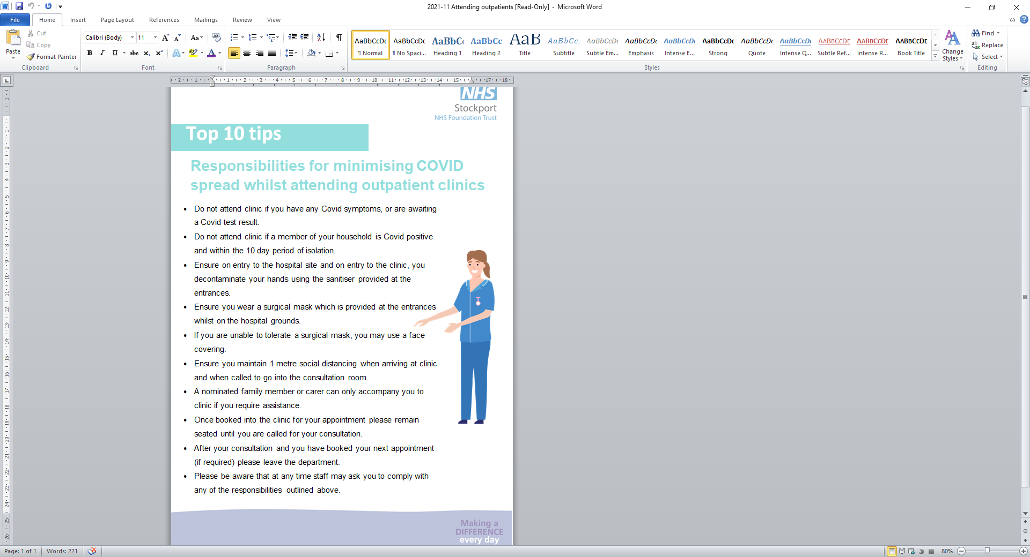

|  |
| --- |
| **If you would like this leaflet in a different format, for example, in large print, or on audiotape, or for people with learning disabilities, please contact:**  Patient and Customer Services, Poplar Suite, Stepping Hill Hospital. Tel: 0161 419 5678. |

|  |
| --- |
| **LIPS_2013_03_04** |

|  |
| --- |
| **Our smoke free policy**  Smoking is not allowed anywhere on our sites. Please read our leaflet 'Policy on Smoke Free NHS Premises' to find out more. |

|  |  |
| --- | --- |
| Leaflet number | PTH102 |
| Publication date | May 2023 |
| Review date | Jan 2024 |
| Department | Anticoagulation Department, Pathology |
| Location | Stepping Hill Hospital |